Project report

on

College Management system

Prepared by:

D.PadmakaraSrinivas(U101115FCS079)B. Nikhil Reddy (U101115FCS070)

Challa Sadhika(U101115FCS075)

Chapala Sai Sowmya(U101115FCS076)

Section: S3

Batch:2015-2019.

Introduction:

This system "College database system" can be used to manage the all types of data in educational institutes. This Project is helpful to Registration of New records into the college. It Contains mainly following section:

* View section
* Staff information
* Student information
* Staff Records(Add/Update/delete)
* Student Records(Add/Update/delete)
* Attendence Records(Add/Update/delete)

Sample problem description:

The main modules involved in this system are:

* Login
* Forms
* Reports

Module Wise Description:

Login: It is used to check whether the user is authorized person to use the system or not. For this user should give the Unique id and Password. The different types of users are

1.Admin

2.Student

3.Employee.

Forms: This Module consists of the following Sub-modules

* Student Registration Form
* Student Fee Form
* Student attendance Form
* Student Id Form
* Employee Detail Form
* Employee Salary Form
* Employee Id Form
* Course Detail Form
* Library Form
* Exam Form
* Sports Form
* Mess Form
* Hostel Form
* Department Form

There is a group of admin’s in the college.There is a one admin in the department.They will enter the details as per department.The student Registration form is designed for registering the new student’s details and course details. Student has to enter the details at the time of admission. They can modify,add,delete data in student registration form.The student Fee form is used to enter the student’s fee details.Admin will enter the student’s fee details. If any student has not paid the fee details before due date,student will not write the exam. The student Marks form is designed for submitting the semester or exam marks of the students for a particular course or an individual student. Every Professor will submit the details of student’s marks to the admin.Admin and professor has only rights to edit the marks of the students.The Student attendance form is designed to enter the attendce details of the student.Professor’s take attendance in the class.Students can check their details in database.students have to maintain 75% attendance,Whoever is not maintaining the attendance they will not suppose to write the exam. They has medical certificates to write the exam.The student id form is used to create the identity number for each student on different course. The employee details form is designed for entering the staff details and other relevant details. Staff can check their details in database.The employee id is used to create the identity number for each student for different course. The Salary form is used to derive the salary for employees. Every month college admin will debited salary into the employe’s account.The course details form is designed for entering the different course available in the campus and other relevant details.Every student must register the 6 courses before admission in databse.Exam form is designed for entering the sitting allotment of the students.Students can see sitting allotment for exam in database.Library form is designed for entering the details of the book issue and whoever issue the book.Admin will issue only 2 books per time.Admin will scan the number infront of the book. Once ‘checkout’ button is preesed,a mail will be sent to owner.They has to return the books for one week. After that they will pay RS.10/- Per day.Sports form is designed for entering the details of the players.Every student must play 2 games.Mess form is designed for entering the details of the food.Hostel form includes the details of the whoever is staying in the hostel.Students who wants to stay in the college, at the time of admission admin will ask their preferences.

Hostel rooms are divided into single room,double room and triple room.

Boys and girls hostels are separate buildings.

If Any student or staff left the college,admin will delete their details.

Department form includes the details of the student and staff. Student must be in one department and staff also.Students will study common subjects.

Reports: Admin’s will generate the following reports.

The following are the reports:

* Student Report
* Employee Report
* Fee Detail Report
* Marks Detail Report
* Attendence Report, course report and Book report.

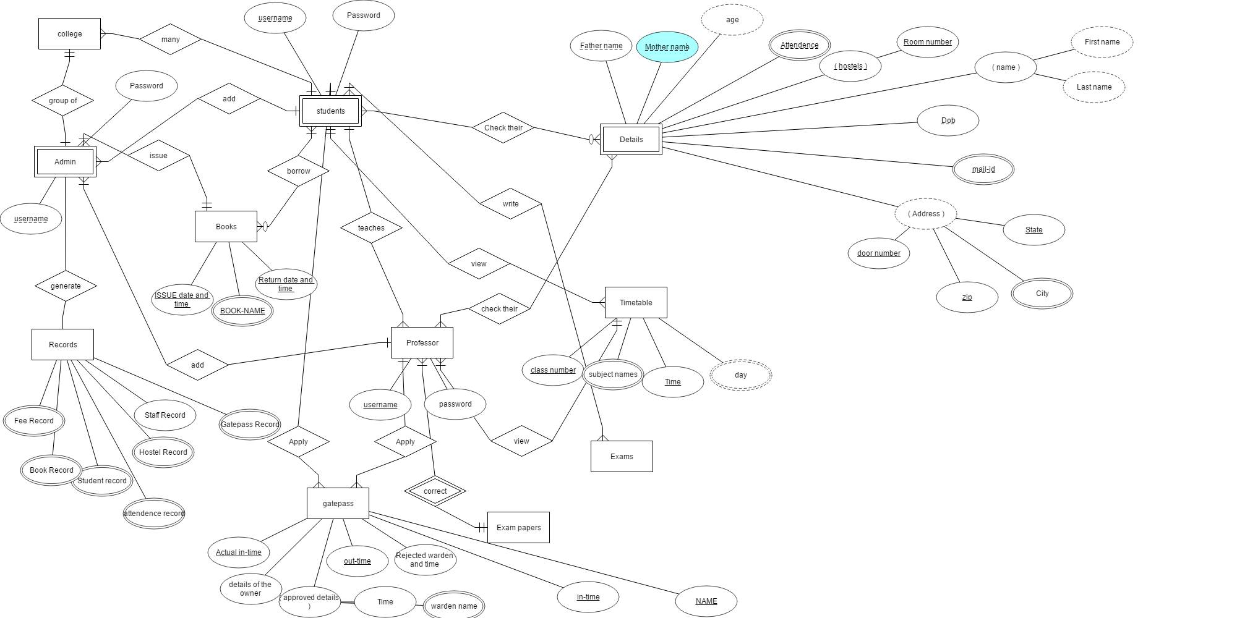

Entity- Relationship diagram.

We used the “ERD plus” software for

Er-diagram.

Conversion of ER-model to Relational tables and Relational schema:

Entitys and attributes:

1.College (Admin ,Students ,Staff )

Primary key(Admin)

|  |  |  |
| --- | --- | --- |
| Admin | students | Staff |

2.Admin (Username, Password)

Primary key(Username,password)

|  |  |
| --- | --- |
| Username | Password |

3.Students(Username,Password)

Primary key(Username,password)

|  |  |
| --- | --- |
| Username | Password |

4.Professor(Username ,Password)

primary key(Username ,Password)

|  |  |
| --- | --- |
| Username | Password |

5.Details(Father name, Mother name, Age, D.O.B, address(city,state,pincode), Mail id, Hostel(Room number), Departments, Name(First name,last name))

|  |  |  |  |  |  |  |  |  |
| --- | --- | --- | --- | --- | --- | --- | --- | --- |
| Father name | Mother name | age | Date of birth | adress | Mail id | Hostel | Department | name |

6.Books(Book name ,Issue date ,Return date)

Primary key(Issue date,Book-name)

|  |  |  |
| --- | --- | --- |
| Book-name | Issue date | Return date |

7. Gatepass(Actual in-time,out-time,In-time,name)

Primary key(out-time,name)

|  |  |  |  |
| --- | --- | --- | --- |
| Actual in-time | Out-time | In-time | Name |

8.Timetable(Class number, subject name, time,day)

Primary key(Day)

|  |  |  |  |
| --- | --- | --- | --- |
| Class Number | Subject Name | Day | Time |

9.Exams()

10.Records(Student Record,Fee Record,Book Record,Staff Record,Hostel Record,Attendence record).

Records

|  |  |  |  |  |  |
| --- | --- | --- | --- | --- | --- |
| Student record | Fee Record | Book-record | Staff record | Hostel record | Attendence record |

Table schema: